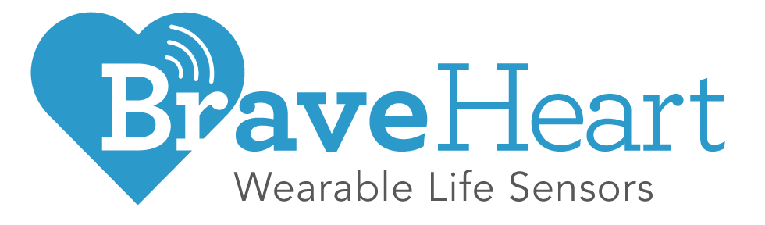
One Line Summary: Leading edge medical grade general purpose IoMT wearable device PLATFORM purposefully architected for Telehealth, Remote Patient Monitoring (RPM) and Clinical Quality Vital Signs Monitoring (VSM)

Business Summary: Our 501(k) certified wearable biosensor patches enable real-time continuous monitoring of physiological patient data to enable Connected Care.

Management:
Our Founder is on his 4th startup as CEO and has raised $100M+ with successful exits. Collectively, the management team has worked at 3Com, BD, BioTelemetry, Boston Scientific, ICU Medical, J&J, Medtronic, Megadyne, PepsiCo, P&G, US Army.

Customer Problem:
TeleHealth and Connected Care solutions are limited by legacy technology. 1st and 2d generation wearables lacked data quality and availability, had no real-time access and limited systems integration potential and a closed architecture.

Product/Services:
We sell a multi-sensor, open platform, continuous data wearable patch and cloud architecture. We have Patented technology and we partner with established Digital Health companies as our go-to market distributors and OEM partners.

Target Market:
TAM: $5 Bil. We have identified 5 Markets for our Platform. Our Beachhead was Cardiac Care and we are moving into other markets, based on our OEM partner channels and strategic targets.

Customers:
Our current paying customers include pharmaceutical and clinical trial management companies (CROs), medical device OEMs, and remote patient monitoring companies. We have active discussions with a host of other potential strategic partners.

Sales/Marketing Strategy:
2019: We developed relationships w strategic OEM partners and shipped development kits to initiate joint development projects. 2020: We are scaling the deployment of development kits through traditional and digital marketing awareness campaigns.

Competitors:
In the Cardiac Care market, competitors include iRhythm, BioTelemetry, Preventice and BardyDX and but none of these is a 3d generation wearable.

Financials:
Available on request for Accredited Investors.
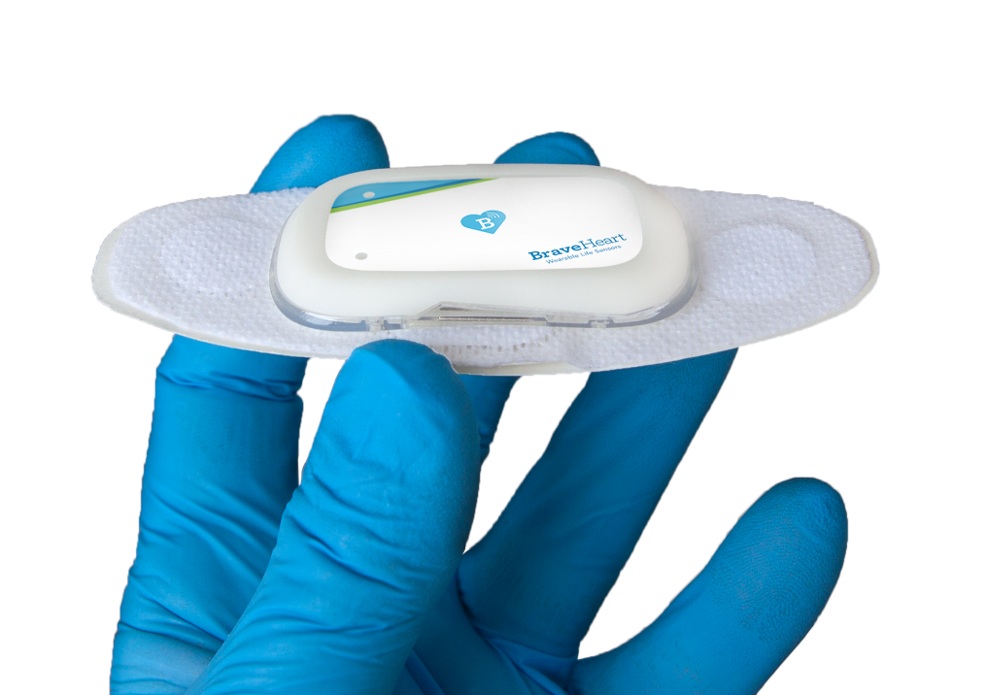

Company Profile:
URL: https://www.braveheart.life/
Industry: Med Device, Digital Health, IoHT
Employees: 10+

Contact:
Ted McAleer
ted.mcaleer@braveheart.life
M: (435)962-0126
Financial Information:
1st Revenue in 2019
Previous Capital: $5.6M
Founders Investment: Extensive by 3 Founders
Pre Money valuation:
Under discussion

Management:
CEO: Steve McCalmont
VP BusDev: Ted McAleer
VP Opns: Dave Shimkus
VP Hardware: Stu MacEachern
VP Software: Ralph Beck

Advisors:
Mike Brown, Bill Drummey, Charles Love, MD; Rosemary Bria, MD; Willem de Laat, MD; Jonathan Steinberg, MD; Robert Spiegal, MD; Jim Young, MD

Investors:
N4 Investment Group, Others

Offices:
BraveHeart Wireless Inc.
7984 S. 1300 E. Sandy, Utah 84094 | M: (435)962-0126

11 Perimeter Road, Nashua, NH 03063 | O: 603.417.4012

