MICROSURGICAL INNOVATIONS VASCULAR COUPLING DEVICE
HOW IT WORKS

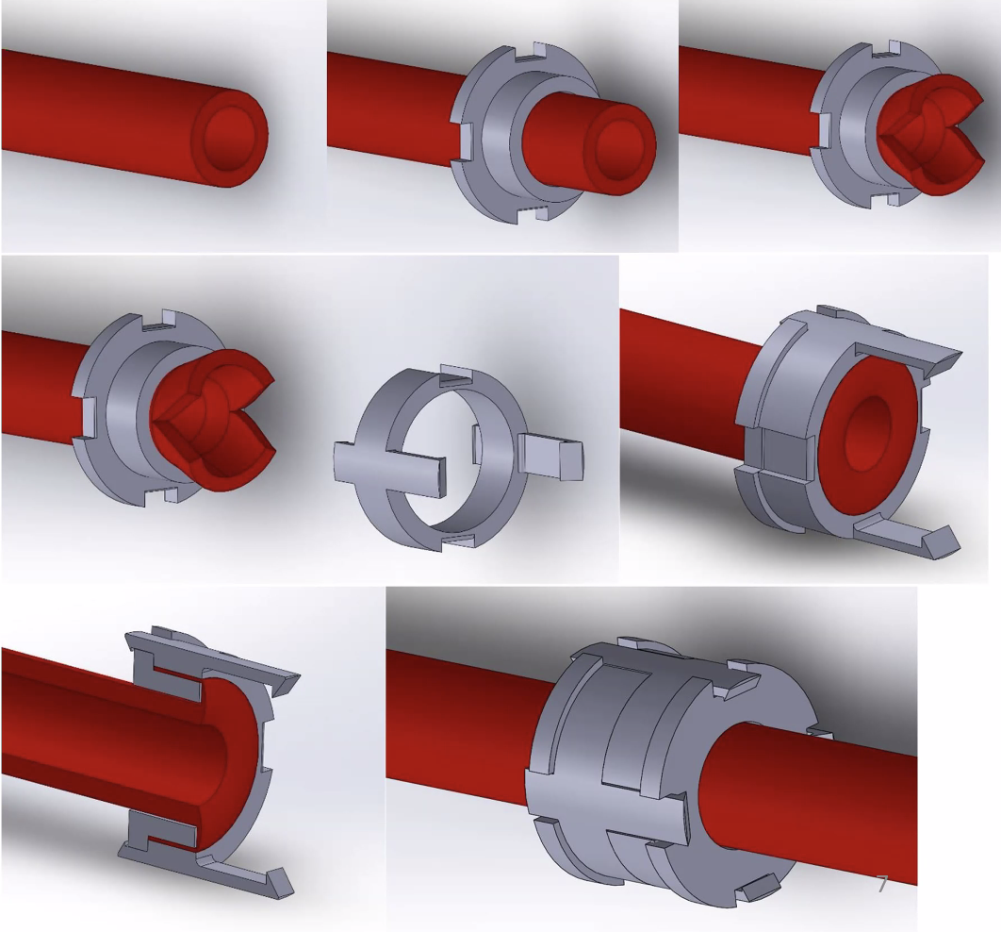

1&2 - The Vessel is threaded through the back ring
3 - Arteries are clipped to reduce circumferential tension since arteries are thicker and more muscular. Veins do not require clipping. The vessel end is folded back over the inner ring, or everted.
4&5 - The engaging ring is placed over the everted vessel and snapped into the inner ring, compressing the vessel end between the rings.
6 – A cross-section showing compression of the vessel end and the snap fit between the back ring and engaging ring.
The same process is accomplished on the other vessel end and the engaging rings of each vessel end snap fit at 90 degrees to complete the anastomosis.

